VIASystem user guide

# **Viewing every event, member or lecturer**

After opening the application, you will be presented with three choices: events, members or lecturers.

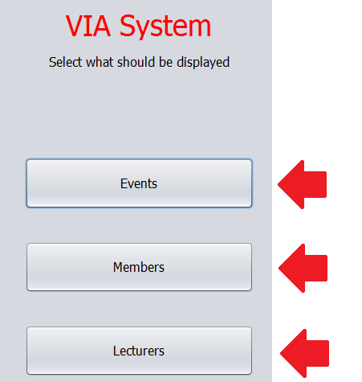

After clicking on any of these buttons you will be presented with the full list of either events, members or lecturers.

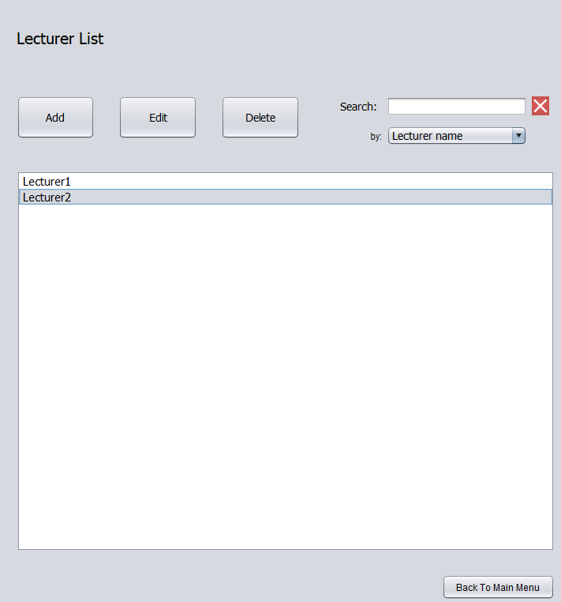

In order to make the list more easily readable only the names or titles of the items that make up the list will be displayed. You can, however, double-click on any item in order to display every information the system stores on it.

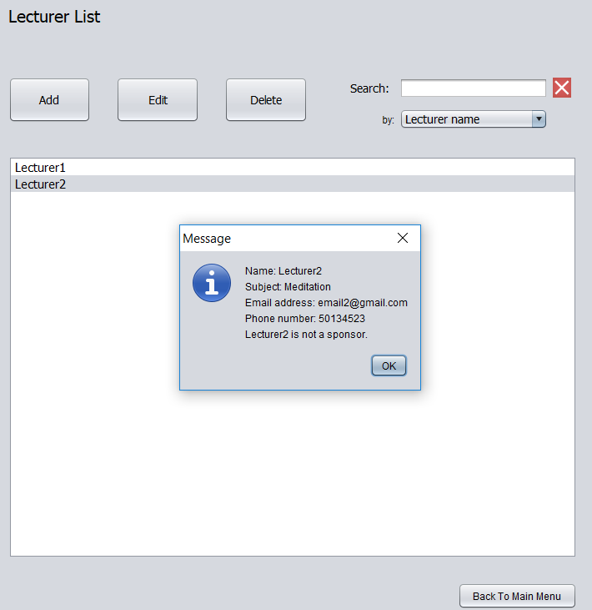

# **Adding a new event, member or lecturer**

Because of the similarities among adding either a member, a lecturer or an event in this guide only the adding of an event will be illustrated.

First, enter the events list and click on the *Add* button.

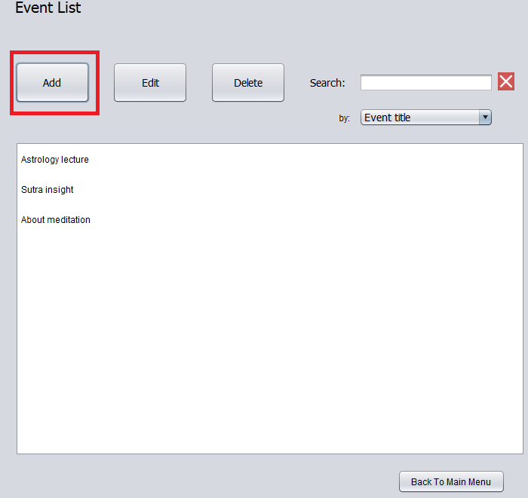

Next, select which type of event you wish to create: lecture, seminar, workshop or trip.

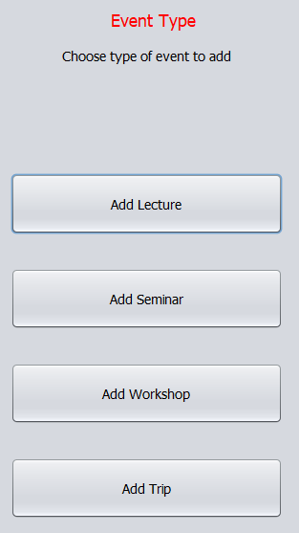

After choosing a type you will then need to fill in a form and click the *Add* button when finished or the *Cancel* button if you change your mind.

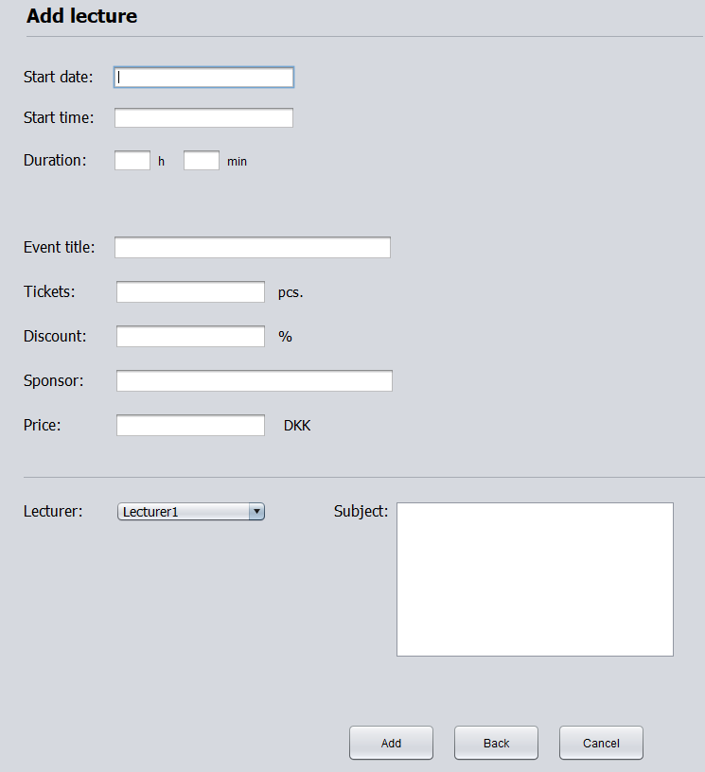

When choosing a lecturer for your event you will be presented with a list of all the lecturers whose information is stored within the system.

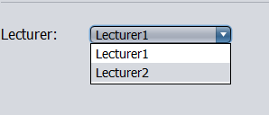

In the case of a seminar or a workshop you can choose multiple lecturers to host your event. In order to do that click on the check boxes on the left side.

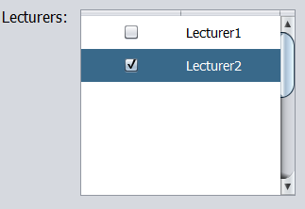

# **Editing an event, member or lecturer**

In order to edit an item from the list just select it by clicking it once and then click the edit button.

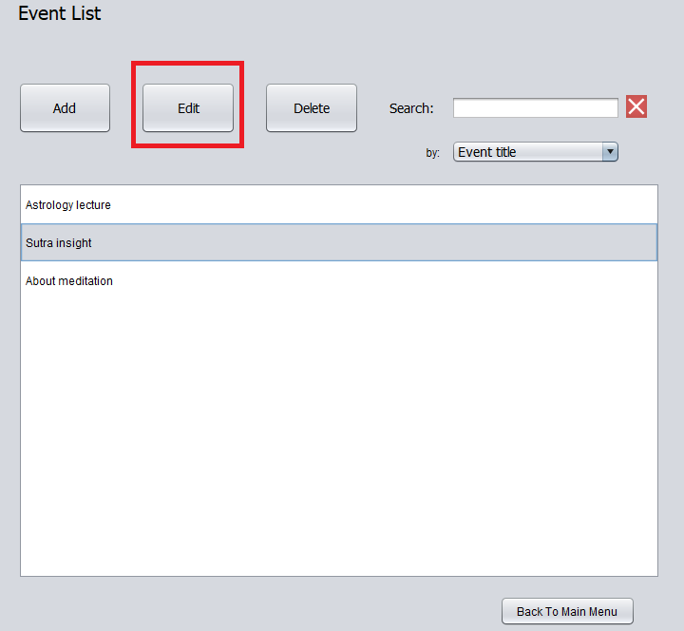

After clicking on the button several pop ups will appear and you can fill in each text field with new information.

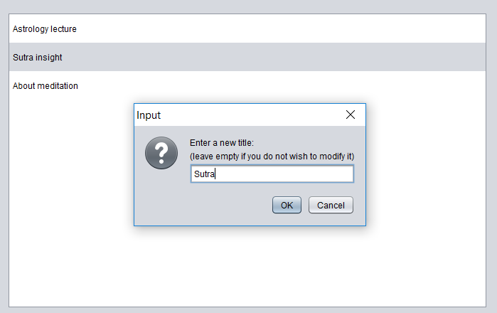 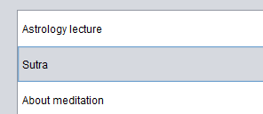

The same process will be used for editing members and lecturers as well.

# **Deleting an event, member or lecturer**

In order to delete an item from the list just select it and then click on the delete button.

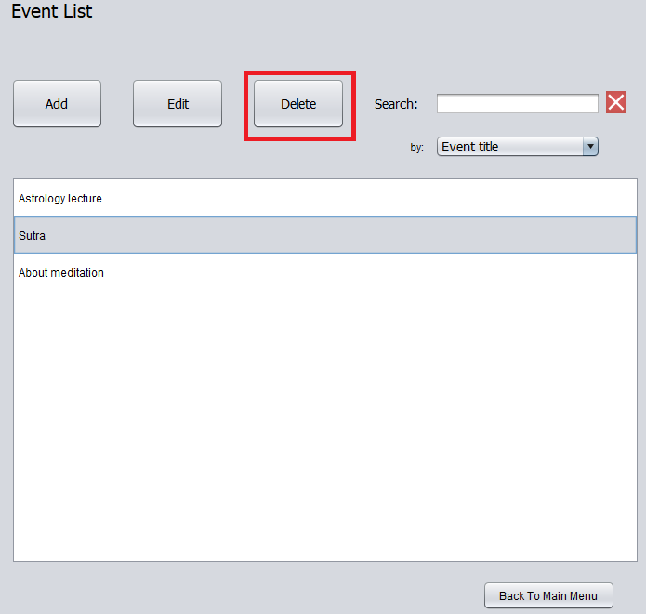

# **Searching for events, members or lecturers**

The system provides the user with a search functions, which allows you to display certain items from a list according to a certain parameter.

In order to use this function, you will have to first click on the dropdown menu under the search text field and choose what parameter you want to search the list by.

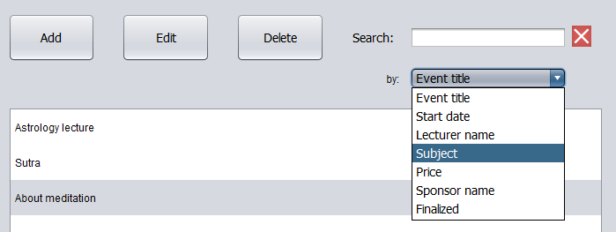

After that type in the text field what you wish to search by and press enter.

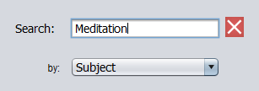

The list will then display every item that meets the requirement.

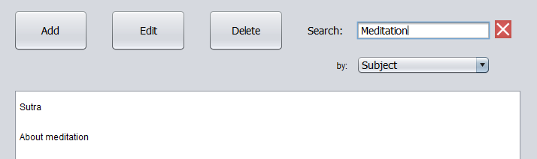

If you want to see the full list again just click on the red *X* button next to the search field.

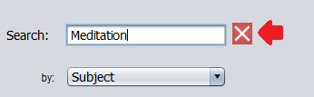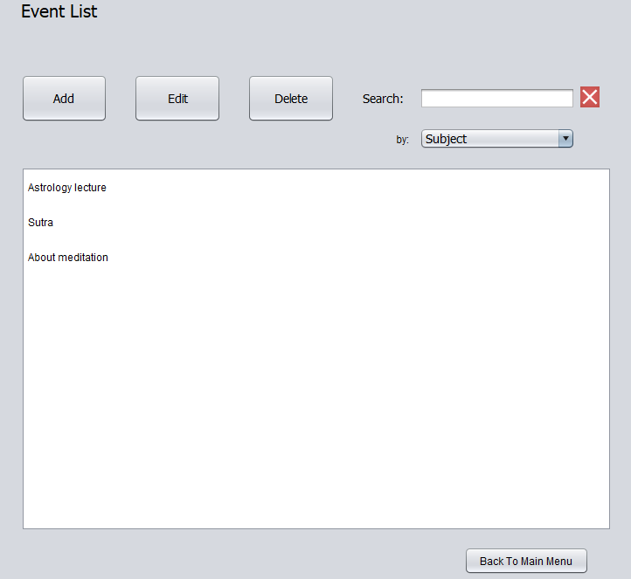

If the parameter is *Finalized* in the case of events or in the case of lecturers *Sponsors* or *Non-Sponsors* just leave the field empty and press enter.

